LOW CODE
EXPERIMENT-2
AKILAA M
240701027

Setting up a Zoho Creator account and exploring the platform architecture and interface.

1.Aim
To create a sample application in Zoho Creator, learn how to create forms and reports, and understand the basic Develop, Deploy, and Manage sections of the Zoho Creator platform.

2. Setting Up Zoho Creator
I. Create the Sample Application
Procedure:
- Open Zoho Creator and sign in to your account.
- Click Create Application and select Create from Scratch.
- Enter an application name and create the application.
- In the application, create a form named Technician.
- Add the required fields such as Technician Name, Technician ID, Phone Number, Email, and Department.
- Save the form and add sample records.
Explanation:
A Zoho Creator application contains different components such as forms, reports, pages, and dashboards. The Technician form is used to collect and store technician-related information.
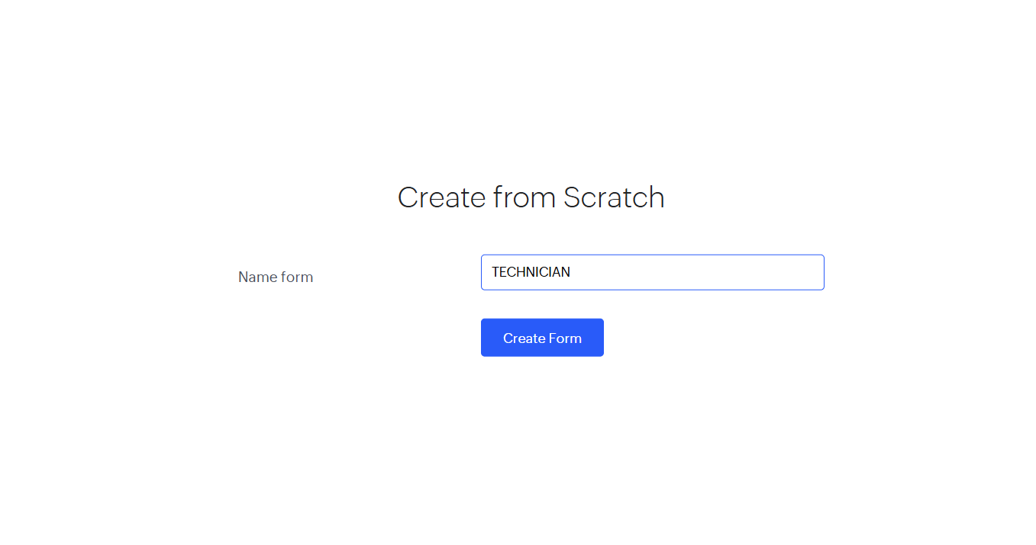

II. Creating a Form
Procedure:
- Open the sample application.
- Go to Develop → Forms.
- Click Create Form.
- Select Blank Form and give it the name Technician.
- Drag and drop the required field types into the form.
- Configure the field names and properties.
- Click Save and publish the form.
Explanation:
A Form is used to collect data from users and store it in the application's database. In this application, the Technician form collects information about technicians.
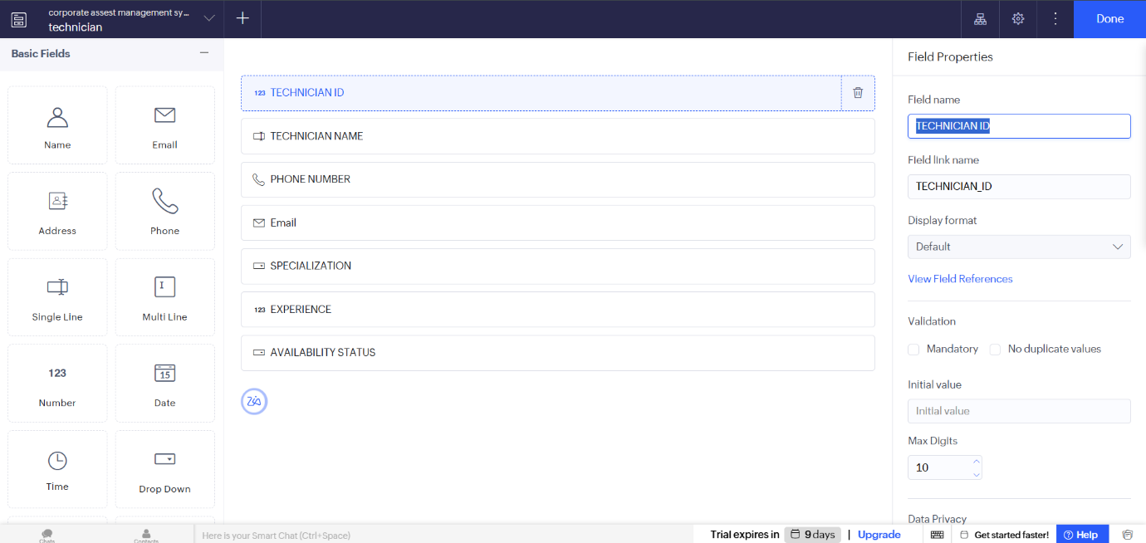

III. Creating a Report
Procedure:
- Go to Develop → Reports.
- Click Create Report.
- Select the Technician form as the data source.
- Choose a report format such as List or Table.
- Select the fields that should be displayed.
- Save the report and view the technician records.

Explanation:
A Report displays the data collected through a form in an organized manner. It helps users view, search, filter, and analyze the stored technician information easily.
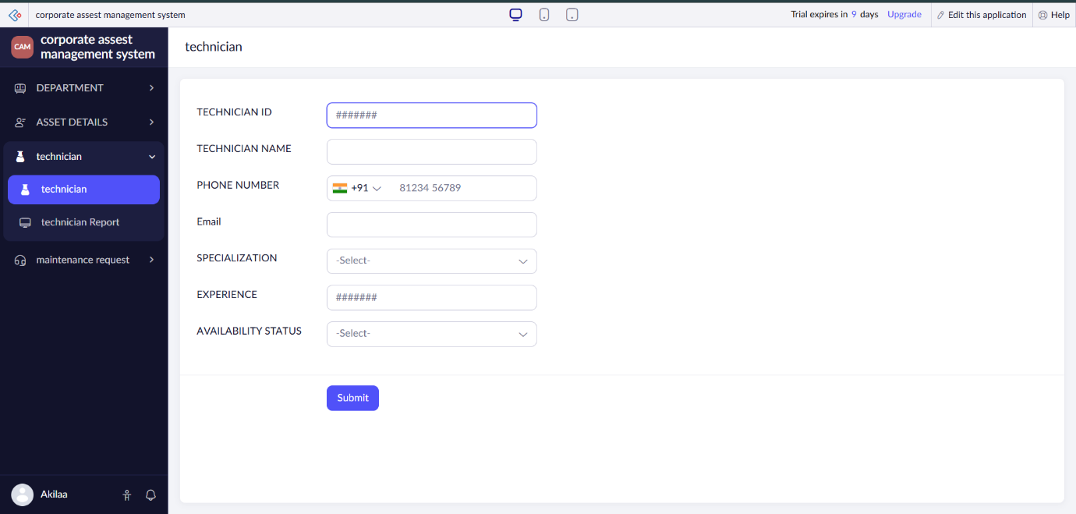

IV. Creating a Dashboard
Procedure:
- Go to Develop → Pages or the dashboard/page creation option.
- Create a new page for the application.
- Add components such as reports, charts, panels, and summary information.
- Select the Technician report as the data source where required.
- Arrange the components according to the requirement.
- Save and preview the dashboard.

Explanation:
A Dashboard provides a visual summary of application data. It can display reports, charts, and important information in one place, making the data easier to understand.
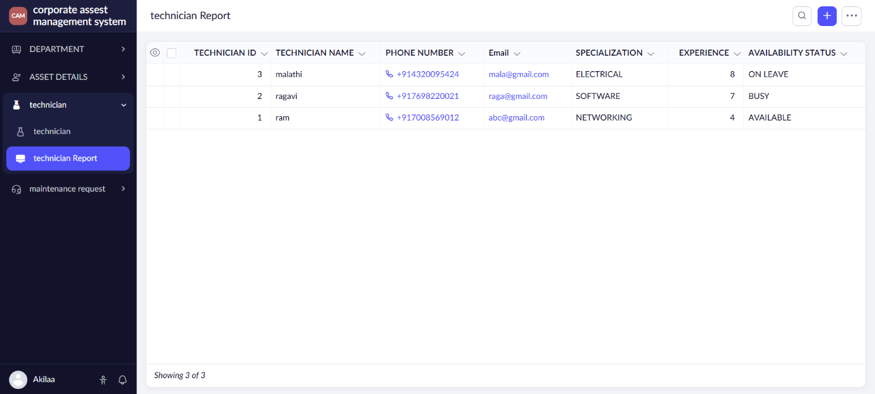

3. Exploring the Platform Architecture and Interface
Develop
The Develop section is used to build and customize the application.
It allows users to create forms, reports, pages, workflows, and other application components.
It is mainly used for designing the application's functionality and data structure.
Deploy
The Deploy section is used to make the application available to users.
Applications can be accessed through web or mobile interfaces based on the configured permissions.
It helps in publishing and providing access to the completed application.
Manage
The Manage section is used to maintain and control the application.
It provides options for managing users, permissions, application settings, security, and data.
It helps administrators monitor and maintain the application effectively.

Result
Thus, a Zoho Creator account was successfully set up, and a sample application with a Technician form, report, and dashboard was created. The basic Develop, Deploy, and Manage sections of the Zoho Creator platform were also explored and understood.

